*SOP Documentation for Career Coach Calls*

# *Index*

* *Purpose*
* *Scope*
* *Procedure*
  + *Aspirant requesting Career Coach Call through app*
  + *Career Coach viewing call requests from Aspirant*
  + *Career Coach connecting with an Aspirant through call from CRM without any query request*
* *Extra Use Cases*

# *Purpose*

This standard operating procedure is intended to assist a Career Coach in understanding and navigating the Career Coach Call function. This SOP would also cover all of the feature's use cases, giving Career Coaches a better understanding of how to use the function.

# *Scope*

This paper outlines the processes required for a Career Coach to access the Career Coach Call Requests. This document also outlines the processes a Career Coach must follow in order to call an aspirant via CRM and settle his query. Furthermore, it offers an aspirant's perspective of requesting a Career Coach Call via the app.

# *Procedure*

## Aspirant requesting Career Coach Call through app

1. *Open Expertrons app*
2. *Navigate to Training Page*
3. *Click on “Request call with Career Coach” button*
4. *Enter Reason for call back*
5. *Click “Request Call back” button*

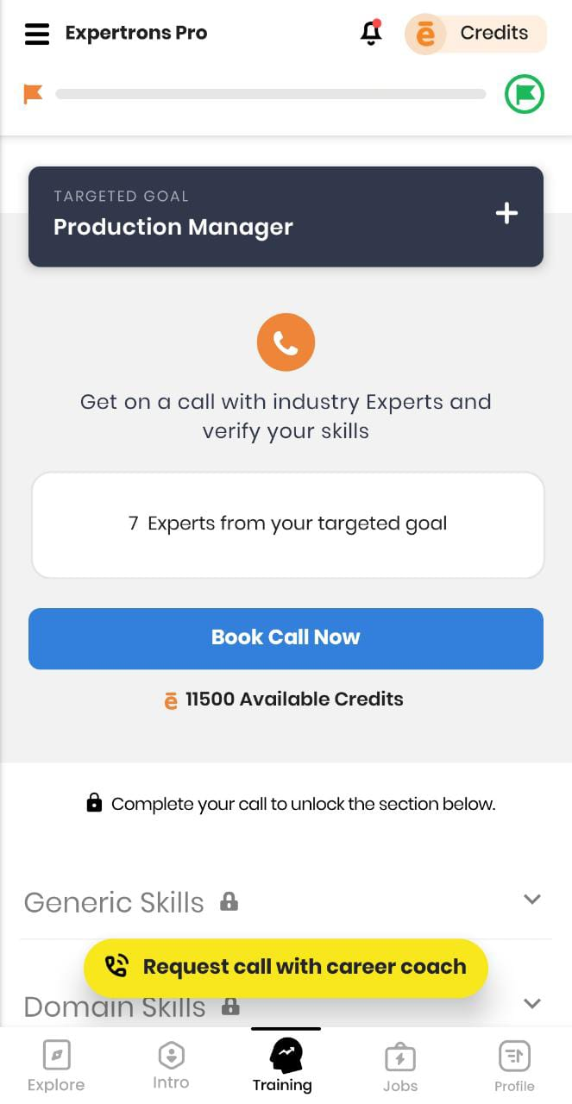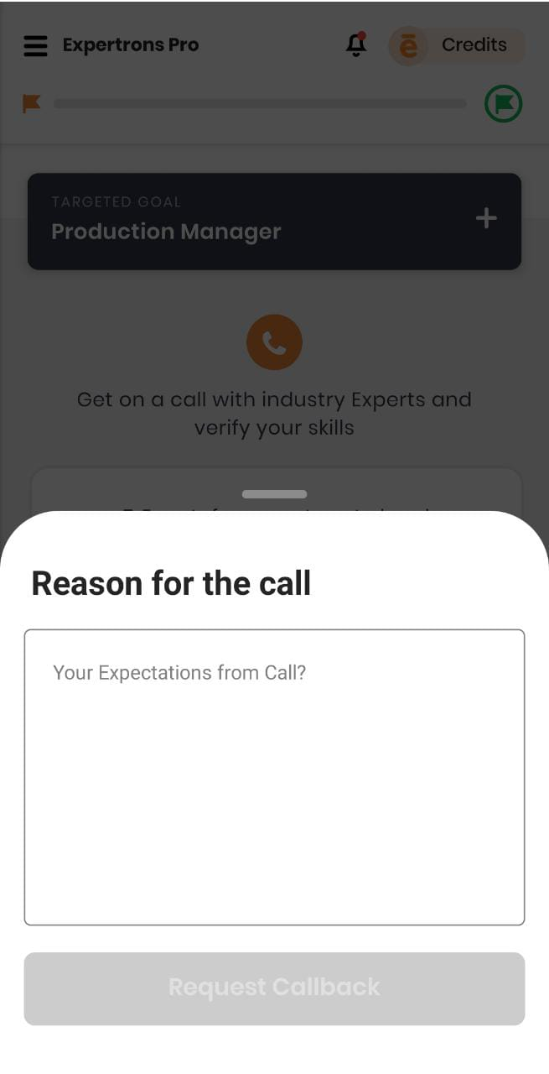

*1.1 Request call button*  *1.2 Enter Reason for Callback*

1. *After booking an expert call*
2. *Generic Skills, Domain Skills section get unlocked*
3. *Click on Profile Skills Section*
4. *Navigate down to Career Coach list*
5. *Place a call*

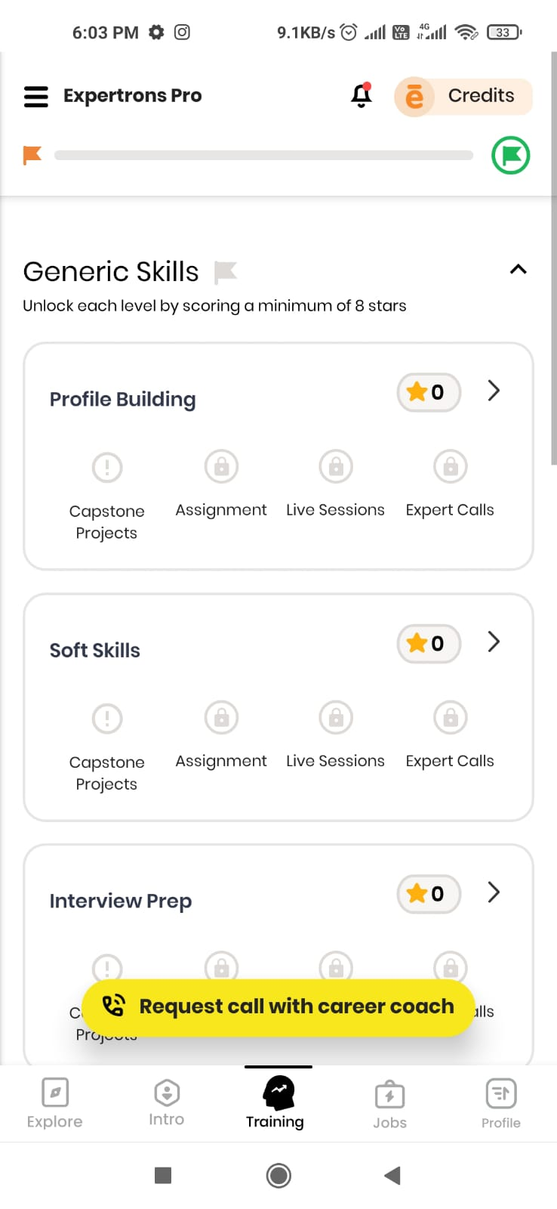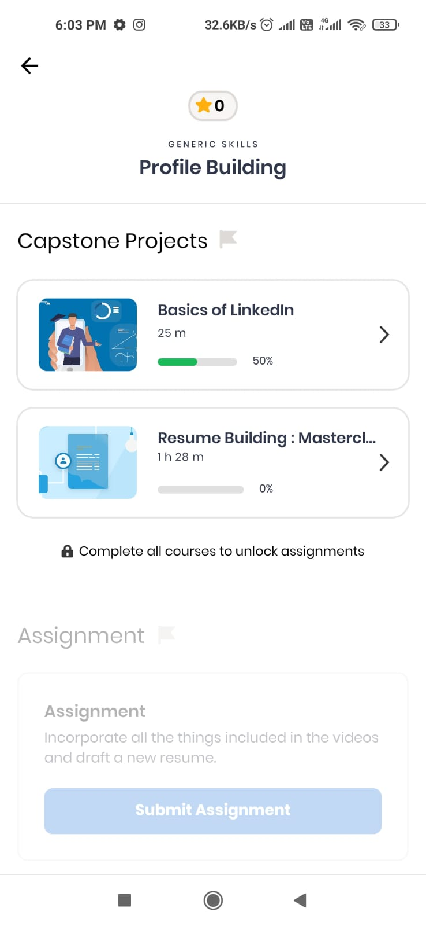

*2.1**Generic and Domain Skills unlocked 2.2 Profile Building Page*

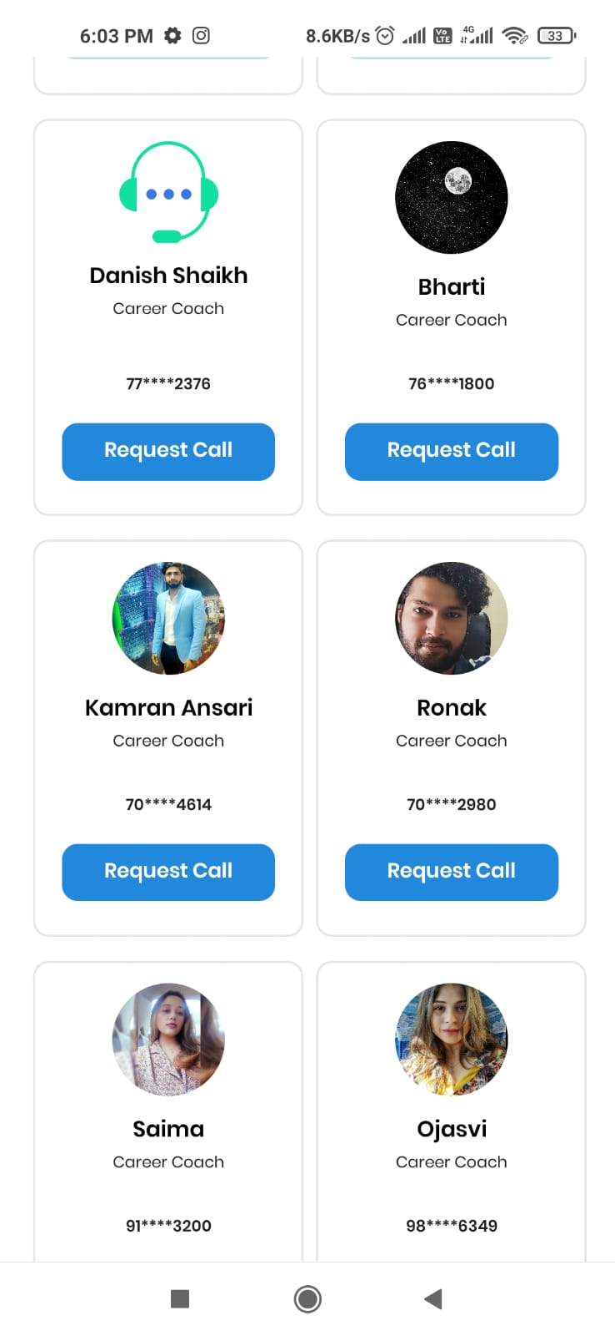

*2.2 Place a call to your Career Coach*

1. *Open Expertrons app*
2. *Navigate to Explore Page*
3. *Locate Career Coach Call Banner at the top*
4. *Click on “Request call with Career Coach” button*
5. *Enter Reason for call back*
6. *Request Call back*

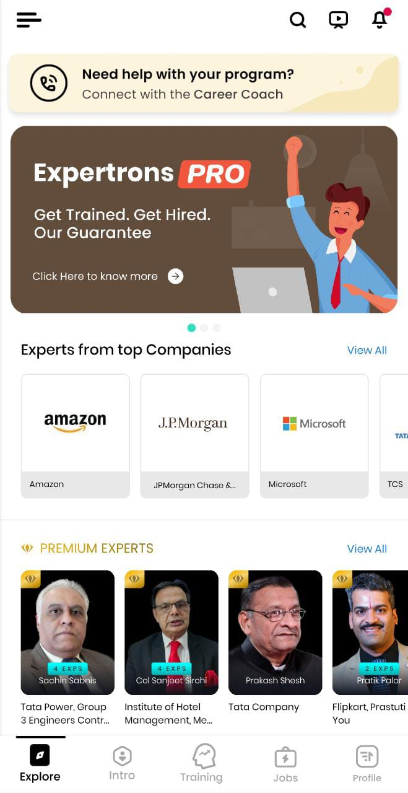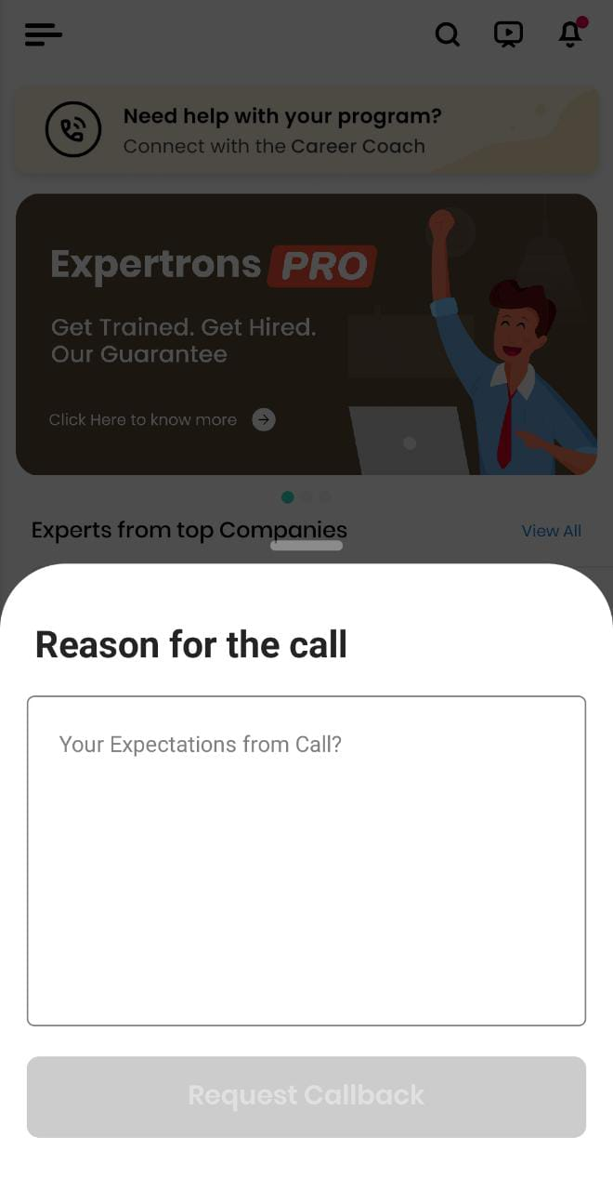

*3.1 Request Call banner at top 3.2 Enter reason for callback*

## Career Coach viewing call requests from Aspirant

1. *Open CRM*
2. *Navigate to “Premium Users”*
3. *Locate “Coaches Call” section*

### ***Call Requests Page*** - All the Career Coach Calls requested by an aspirant through the app would be displayed here. Any Career Coach would be able to view the below details -

* **User Name:** Aspirant name who requested the call
* **Domain:** Domain of the aspirant
* **Phone No. :** Phone no. of the aspirant
* **Coaches Name:** Assigned Career Coach name
* **Date:** Call Request date
* **Call Date time:** Call Request answered by Coach’s date and time
* **Description:** Call Back request reason entered by aspirant
* **Time:** Call Request time
* **Action:** “Call” option which places the Call to an aspirant
* **Resolution Status:** “Resolve” option - On clicking this, another box opens, in which a Career coach has to mention the reply to the aspirant's call back request.

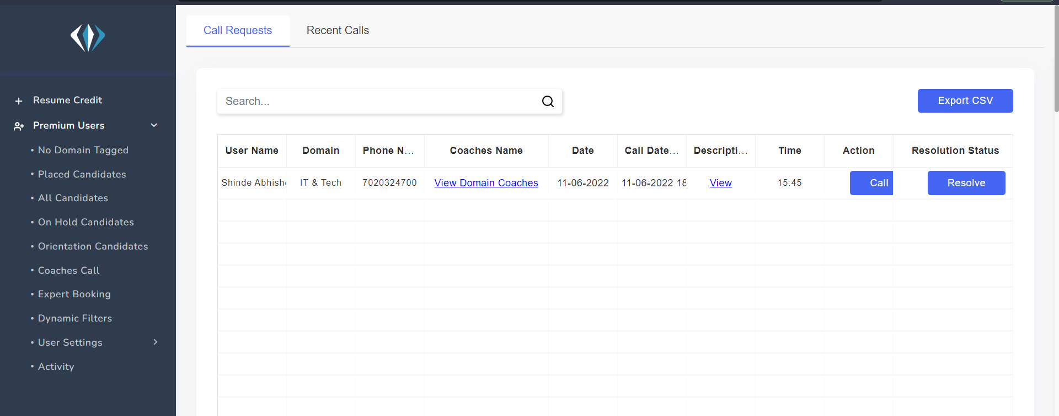

*Call Requests Tab*

### ***Recent Calls Page*** - All calls placed by a Career Coach to an aspirant would be displayed here. Any Career Coach would be able to view the below details

* **User Name:** Aspirant name who requested the call
* **Domain:** Domain of the aspirant
* **Coach:** Assigned Career Coach name
* **Call Request Date:** Call Request date
* **Call Made:** Date on which Career Coach placed a call for resolving the query
* **Call Time:** Time at which the Call was placed by the Career Coach for the aspirant
* **Covered Duration:** Duration of the Call
* **Disconnected From:** name of the authority that disconnected the call
* **Call Status:** If call picked by aspirant and Career Coach both then it displays as ***Answered*** after the call ends else it is displayed as ***Not Answered.*** Also if a call is in progress with the aspirant, then it is displayed as ***“In Progress”*** on CRM.
* **Recording:** Recording of the call
* **Action:**
* **Resolution Status:** Option to Resolve appears here again. If the call is resolved by the Career Coach It becomes blocked and cannot be clicked again

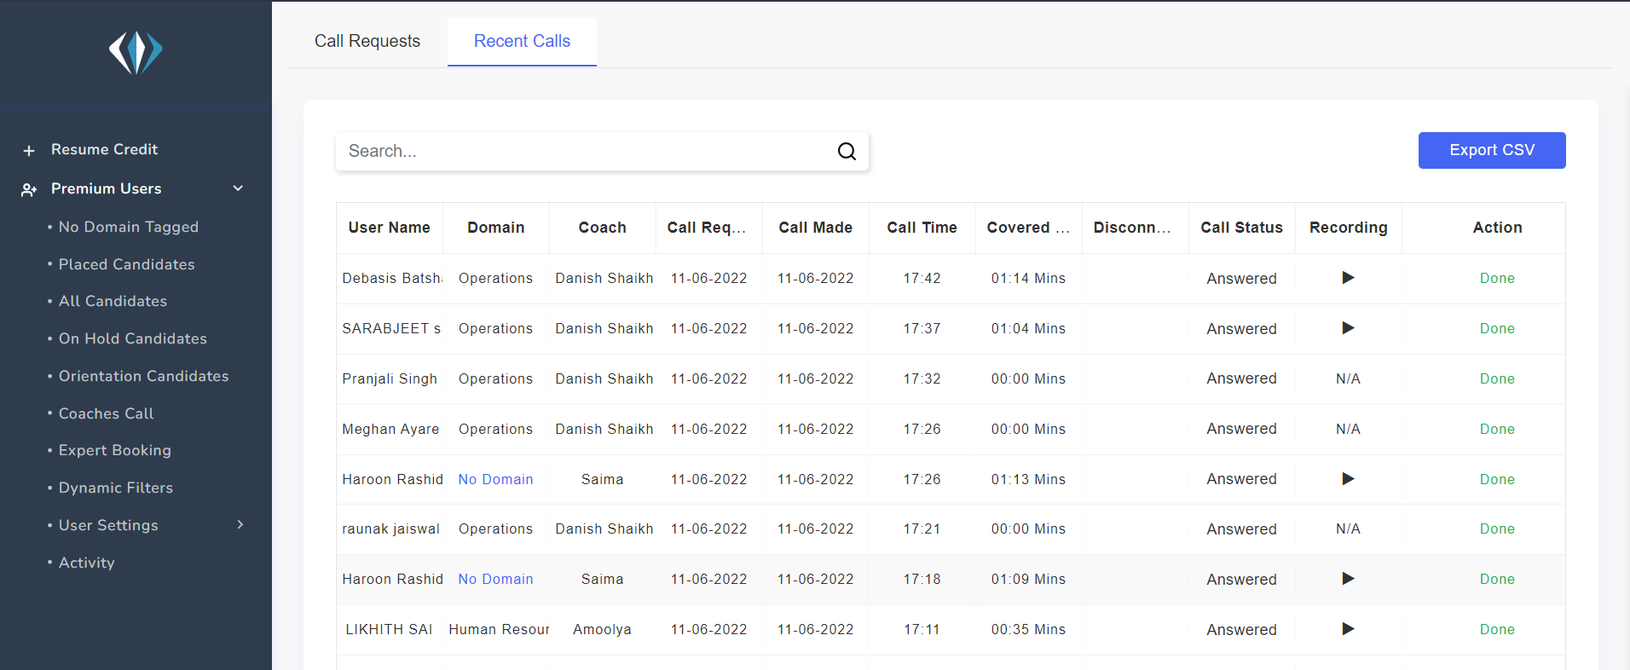

## Career Coach connecting with an Aspirant through call from CRM without any query request

Call Should be placed from ‘All Candidates’ view. The Call button is present in front of every candidate. On pressing the call button, a pop - up comes which asks for confirmation to call a candidate. Upon pressing “Yes” the call is placed to the aspirant. If both the stakeholders (aspirants and career coaches) pick the call, then it is displayed as “Answered” in Recent Calls tab and if any one of them does not pick the call, then it is displayed as “Not Answered” in Recent Calls tab

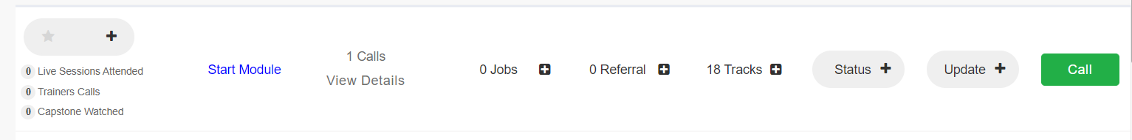

*Call button in front of every candidate in ‘All Candidates’ view*

# 

# ***Some Extra Use Cases:***

## ***Unresolved Call***

*If a call is once answered by the aspirant, but not marked as resolved by Career Coach then it is still an unresolved call.*

## ***In Progress***

*Calls requested by an aspirant are present in the Call Requests tab. When a call is placed by Career Coach through* ***“All Candidates”*** *view then, also the call appears in* ***“Call Requests tab”****, but the call is already Resolved and the Action is defined as* ***“In Progress”***

## ***Resolve***

*After placing a call from the Call Request tab, the Call details go to the Recent Calls tab irrespective of the fact that the Call is “Answered” or Not. A Career Coach has to Resolve the Call from the “Recent Calls” Tab.*

## ***Call Already Placed***

*If a call is placed to an aspirant from* ***“All Candidate”*** *view without resolving the call, then a notification pops-up which conveyed* ***“Call is Already Placed”.***

## ***Tech Issues***

*Sometimes, when a call is placed, the call faces some technical issue then it*

*might be possible that Action is displayed as* ***“In Progress”*** *in the Call Requests tab. Also this* ***“In Progress”*** *is displayed for max. 30 minutes and after that* ***“Call”*** *button again appears*

## ***Call Requests***

*An aspirant can place another career coach call only after 3 hours after request of first Call. If an aspirant wants to place a call within 3 hours after the first request of a Call then the first Career Coach Call needs to be resolved on CRM by the Career coach.*

# ***Futuristic Improvements***

## ***1 hour Call***

*The maximum duration for a Career Coach Call is 30 minutes. This should be increased to 1 hour since Career Coach Calls can extend upto 1 hour*

## ***“In Progress” issue***

*There are many cases in which the call is marked as “In Progress” without the call getting actually placed to the aspirant.*